Go to SE11.

1. Create structure for Address.
2. Enter Structure Name as ZXXXXXXADDRESS . XXXXXX is your Empcode.

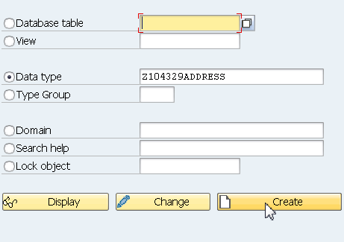

In the subsequent screen, select the Radio Button Structure.

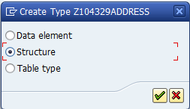

Enter Details as shown below.

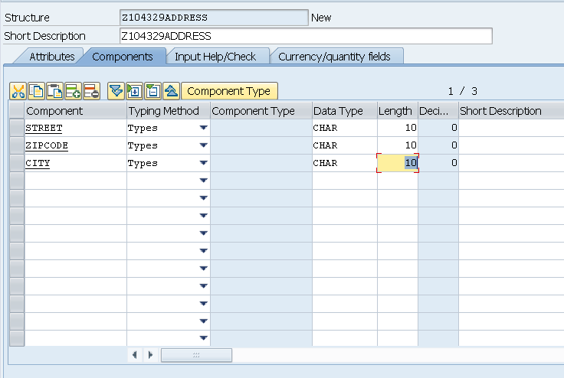

Save and Activate the above structure.

1. Create another structure for Name.
2. Enter Structure Name as ZXXXXXXNAME where XXXXXX is your Empcode.

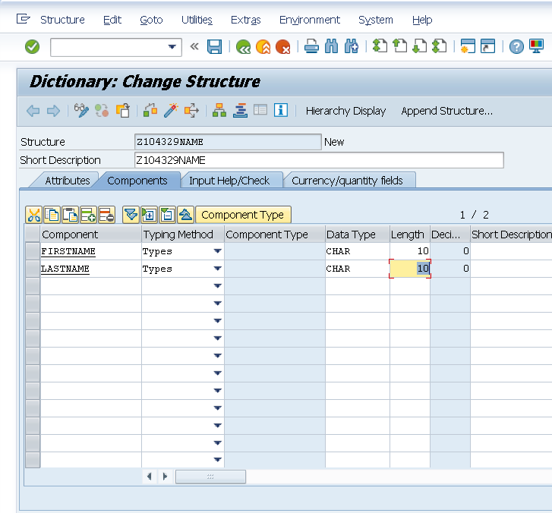

REPORT Z.

DATA WA_ADR TYPE Z104329ADDRESS.

DATA WA_NM TYPE Z104329NAME.

WA_ADR-STREET = 'Neurott Str 15 a'.

WA_ADR-ZIPCODE = 'D-69190'.

WA_ADR-CITY = 'Walldrof'.

WA_NM-FIRSTNAME = 'Hans'.

WA_NM-LASTNAME = 'Hans'.

WRITE WA_ADR-STREET.

WRITE WA_ADR-ZIPCODE.

WRITE WA_ADR-CITY.

WRITE WA_NM-FIRSTNAME.

WRITE WA_NM-LASTNAME.